**Database management system Lab CSE-403L**

**Semester:6th**



**Lab Report # 7**

**Submitted By:** *Zainab Khalid*

**Registration No:***19PWCSE1743*

**Section: A**

**Submitted to:** *Mam Naina Said*

**Department of Computer Systems Engineering**

**University of Engineering and Technology Peshawar**

**Tasks**

1) Display the data from a database in a html table using php.

<!-- PHP code to establish connection with the localserver -->

<?php

// Username is root

$user = 'root';

$password = '';

// Database name is lab6

$database = 'lab6';

// Server is localhost with

// port number 3306

$servername='localhost:3306';

$mysqli = new mysqli($servername, $user,

                $password, $database);

// Checking for connections

if ($mysqli->connect_error) {

    die('Connect Error (' .

    $mysqli->connect_errno . ') '.

    $mysqli->connect_error);

}

// SQL query to select data from database

$sql = " SELECT * FROM membertable ";

$result = $mysqli->query($sql);

$mysqli->close();

?>

<!-- HTML code to display data in tabular format -->

<!DOCTYPE html>

<html lang="en">

<head>

    <meta charset="UTF-8">

    <title>database</title>

    <!-- CSS FOR STYLING THE PAGE -->

    <style>

        table {

            margin: 0 auto;

            font-size: large;

            border: 1px solid black;

        }

        h1 {

            text-align: center;

            color: rgb(25, 27, 26) ;

            font-size: xx-large;

            font-family: 'Gill Sans', 'Gill Sans MT',

            ' Calibri', 'Trebuchet MS', 'sans-serif';

        }

        td {

            background-color:coral;

            border: 1px solid black;

        }

        th,

        td {

            font-weight: bold;

            border: 1px solid black;

            padding: 10px;

            text-align: center;

        }

        td {

            font-weight: lighter;

        }

    </style>

</head>

<body>

    <section>

        <h1>Database lab6</h1>

        <!-- TABLE CONSTRUCTION -->

        <table>

            <tr>

                <th>Memberid</th>

                <th>First Name</th>

                <th>Last Name</th>

                <th>Handicap</th>

                <th>Gender</th>

                <th>Team</th>

                <th>Mtype</th>

                <th>Coach</th>

                <th>Phone</th>

                <th>Join Date</th>

            </tr>

            <!-- PHP CODE TO FETCH DATA FROM ROWS -->

            <?php

                // LOOP TILL END OF DATA

                while($rows=$result->fetch_assoc())

                {

            ?>

            <tr>

                <!-- FETCHING DATA FROM EACH

                    ROW OF EVERY COLUMN -->

                <td><?php echo $rows['memberid'];?></td>

                <td><?php echo $rows['f_name'];?></td>

                <td><?php echo $rows['l_name'];?></td>

                <td><?php echo $rows['handicap'];?></td>

                <td><?php echo $rows['gender'];?></td>

                <td><?php echo $rows['team'];?></td>

                <td><?php echo $rows['mtype'];?></td>

                <td><?php echo $rows['coach'];?></td>

                <td><?php echo $rows['phone'];?></td>

                <td><?php echo $rows['join_date'];?></td>

            </tr>

            <?php

                }

            ?>

        </table>

    </section>

</body>

</html>

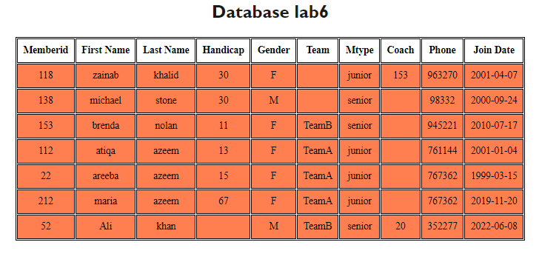

2) Create a drop down list in html where the content should come from a

database table.

<style>

    body{

    background-color:rgb(124, 114, 114);

    margin:10px;

    padding:7px;

    font-size: larger;

    font-weight: 200;

    font-style: normal;

    }

    select{

        padding: 3px;

        margin:auto;

        color: rgb(30, 32, 32);

        border: 1px solid black;

        border-radius: 3px;

        font-family:'Times New Roman', Times, serif;

    }

    </style>

<?php

echo "<h1>DROP DOWN MENU</h1>";

$mysqli= NEW MySQLi('localhost','root','','db2022');

$resultSet=$mysqli->query("SELECT empName FROM emp");

echo "<br>";

$result=$mysqli->query("SELECT empJob FROM emp");

$result1=$mysqli->query("SELECT empID FROM emp");

?>

<label><b>Name: </b></label>

<select name="emp">

    <?php

    while ($rows = $resultSet->fetch_assoc())

     {

        $empName=$rows['empName'];

        echo "<option value='$empName'>$empName</option>";

    }

    ?>

</select>

</br>

</br>

<label><b>Job: </b> </label>

<select name="emp">

    <?php

    echo "<br>";

    while ($rows = $result->fetch_assoc())

     {

        $empJob=$rows['empJob'];

        echo "<option value='$empJob'>$empJob</option>";

    }

    ?>

</select>

</select>

</br>

</br>

<label><b>ID: </b> </label>

<select name="emp">

    <?php

    echo "<br>";

    while ($rows = $result1->fetch_assoc())

     {

        $empID=$rows['empID'];

        echo "<option value='$empID'>$empID</option>";

    }

    ?>

</select>

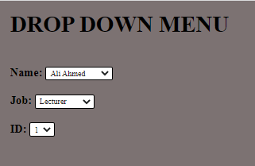

3) Create a form which takes “id” from user and then delete the record from

database. Once the user press “delete” button, he gets redirected to

another page with message “record deleted successfully” and the

updated table content is shown.

<!DOCTYPE html>

<html>

  <head>

    <title> PHP DELETE DATA </title>

        <meta charset="UTF-8">

        <meta name="viewport" content="width=device-width, initial-scale=1.0">

        <style>

          h1{

            padding-top: 8%;

            color: black;

            font-family:'Times New Roman', Times, serif;

            margin: auto;

          }

        body{

          background-color: bisque;

          margin: auto;

          text-align: center;

          font-size: larger;

          font-style: italic;

          color: rgb(255, 153, 0);

        }

        form{

          margin:auto;

          padding: 10px;

          color: rgb(3, 3, 3);

          font-style: initial;

        }

        </style>

  </head>

  <body>

    <h1>Data Deletion</h1>

    <form action="redirect.php" method="post">

      <label>Enter ID:</label>

      <input type="text" name="id" required><br><br>

      <input type="submit" name="delete" value="Delete">

    </form>

  </body>

</html>

**Redirection page:**

<?php

// php code to Delete data from mysql database

if(isset($_POST['delete']))

{

    $hostname = "localhost";

    $username = "root";

    $password = "";

    $databaseName = "lab6";

    // get id to delete

    $id = $_POST['id'];

    // connect to mysql

    $connect = mysqli_connect($hostname, $username, $password, $databaseName);

    // mysql delete query

    $query = "DELETE FROM `membertable` WHERE `memberid` = $id";

    $result = mysqli_query($connect, $query);

    if($result)

    {

        echo '<h1> Data Deleted Successfully</h1>';

    }

    else{

        echo 'ERROR: Data Not Deleted because invalid id ';

    }

    mysqli_close($connect);

}

?>

<style>

h1{

    color: rgb(189, 4, 4);

    font-size: xx-large;

    font: bolder;

    text-align: center;

    padding:15%;

    margin: auto;

    font-family:Georgia, 'Times New Roman', Times, serif

}

body{

background-color:rgb(252, 245, 245);

}

</style>

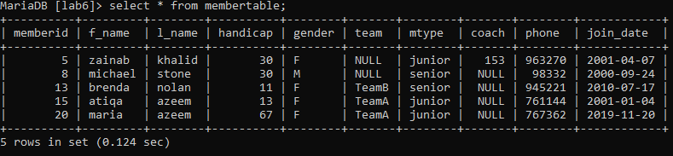





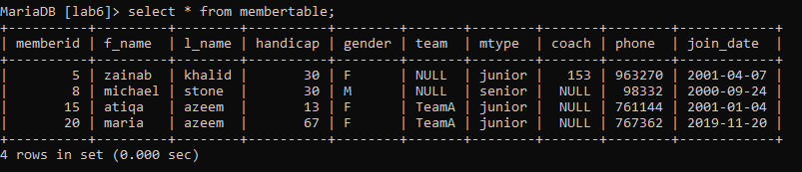

4) Repeat task three but this time for “update” operation.

**Code:**

<!DOCTYPE html>

<html>

  <head>

    <title> PHP UPDATE DATA </title>

        <meta charset="UTF-8">

        <meta name="viewport" content="width=device-width, initial-scale=1.0">

        <style>

          h1{

            padding-top: 8%;

            color: black;

            font-family:'Times New Roman', Times, serif;

            margin: auto;

          }

        body{

          background-color: whitesmoke;

          margin: auto;

          text-align: center;

          font-size: larger;

          font-style: italic;

          color: rgb(255, 153, 0);

        }

        form{

          margin:auto;

          padding: 10px;

          color: rgb(3, 3, 3);

          font-style: initial;

        }

        </style>

  </head>

  <body>

    <h1>UPDATE DATA:</h1>

    <form action="datatobeupdate.php" method="post">

      <label>Enter ID:</label>

      <input type="text" name="id" required><br><br>

      <input type="submit" name="Next" value="Next">

    </form>

  </body>

</html>

**Data to be updated:**

<!DOCTYPE html>

<html lang="en">

<head>

    <meta charset="UTF-8">

    <meta http-equiv="X-UA-Compatible" content="IE=edge">

    <meta name="viewport" content="width=device-width, initial-scale=1.0">

    <title>Document</title>

    <style>

          h1{

            padding-top: 8%;

            color: black;

            font-family:sans-serif

            margin: auto;

          }

        body{

          background-color: whitesmoke;

          margin: auto;

          text-align: center;

          font-size: larger;

          font-style: italic;

          color: rgb(255, 153, 0);

        }

        form{

          margin:auto;

          padding: 10px;

          color: rgb(3, 3, 3);

          font-style: initial;

        }

        </style>

</head>

<body>

  <form action="redirect.php">

  <h1>Enter data to be updated: </h1>

    <!-- <label>New ID:</label>

    <input type="text" name="m_id" ><br><br> -->

    <label>First Name:</label>

    <input type="text" name="f_name" ><br><br>

    <label>Last Name:</label>

    <input type="text" name="l_name" ><br><br>

    <!-- <label>Gender:</label>

    <input type="text" name="gender" ><br><br>

    <label>Handicap:</label>

    <input type="text" name="handicap" ><br><br>

    <label>Team:</label>

    <input type="text" name="team" ><br><br>

    <label>Coach:</label>

    <input type="text" name="coach" ><br><br>

    <label>Phone:</label>

    <input type="phone" name="phone" ><br><br>

    <label>Join Date:</label>

    <input type="date" name="date" ><br><br>

    <label>Member Type:</label>

    <input type="text" name="mtype" ><br><br> -->

    <input type="submit" name="Update" value="Update">

  </form>

</body>

</html>

**Redirection page:**

<?php

// php code to update data from mysql database

if(isset($_POST['update']))

{

    $hostname = "localhost";

    $username = "root";

    $password = "";

    $databaseName = "lab6";

    // get id to update

    $id = $_POST['id'];

    // $id1=$_POST['m_id'];

    $f_name = $_POST['f_name'];

    $l_name = $_POST['l_name'];

    //$gender = $_POST['gender'];

    // $coach = $_POST['coach'];

    // $phone = $_POST['phone'];

    // $mtype = $_POST['mtype'];

    // $team = $_POST['team'];

    // $data = $_POST['date'];

    // $handicap = $_POST['handicap'];

    // connect to mysql

    $connect = mysqli_connect($hostname, $username, $password, $databaseName);

    // mysql update query

    $query = "UPDATE `membertable` SET  `f_name`='$f_name', `l_name`='$l_name'  WHERE `memberid`='$id' ";

    $result = mysqli_query($connect, $query);

    if($result)

    {

        echo "<h1> Data Updated Successfully</h1>";

    }

    else{

        echo "ERROR: Data Not Updated ";

    }

    mysqli_close($connect);

}

?>

<style>

h1{

    color: rgb(189, 4, 4);

    font-size: xx-large;

    font: bolder;

    text-align: center;

    padding:15%;

    margin: auto;

    font-family:Georgia, 'Times New Roman', Times, serif

}

body{

background-color:whitesmoke;

}

</style>

Outputs:





